1. **Agenda**:
   1. We will see **Session.CLIENT_ACKNOWLEDGE**?
2. In Consumer App, change **Session.AUTO_ACKNOWLEDGE** to **CLIENT_ACKNOWLEDGE.** We don’t need to do this in **Producer App**.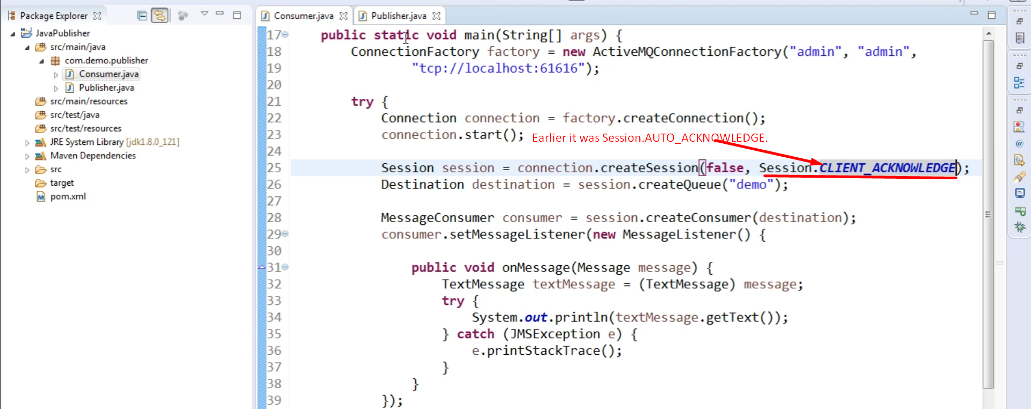
3. 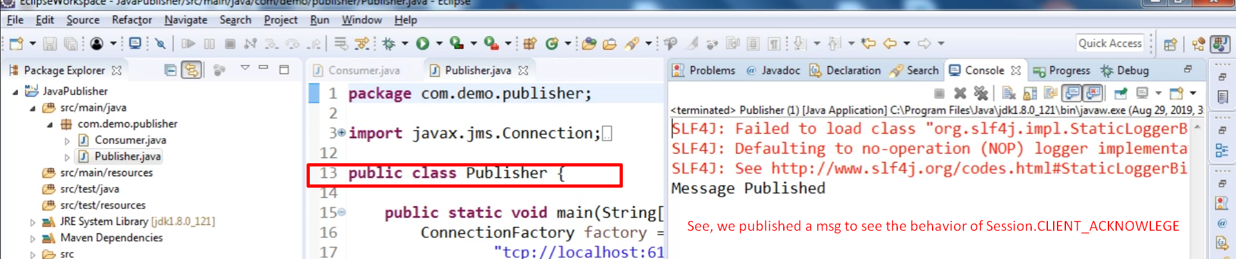
4. Consumer Consuming Msg  
   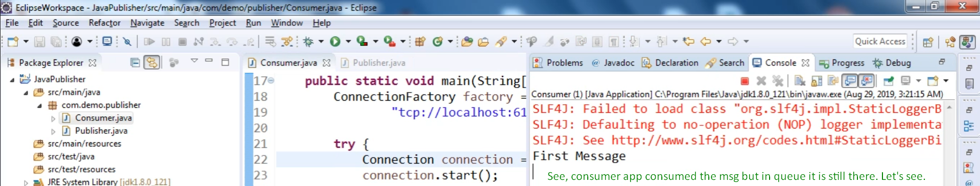
5. Still msg is in pending status.  
   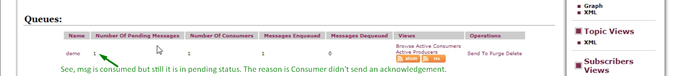
6. Acknowledge the msg manually.  
   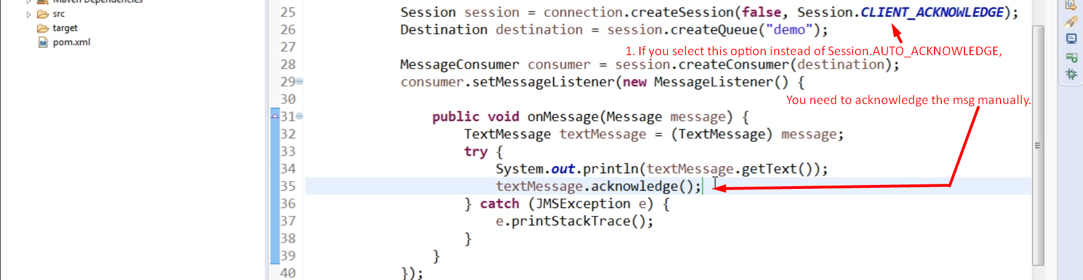
7. A picture containing text

   Description automatically generated